#Vizualisation of search words/related words

#When creating a list of the different search words/possible relevant words I found it

#practical to work in Excel as part of the development and revision of the table

#The results can be converted into R format, using packages that read Excel files and the formatting in Excel

#xlsx format readed by the function

Synonymordtabell <- read_excel("C:/Users/marku/OneDrive - Universitetet i Oslo/Synonymordtabell - kopi.xlsx")

NA simply means empty cells in the Excel documents, as there were different number of words under each of the categories

View(Synonymordtabell)

Under the “Eksempler på utfordringen med søkeord»-column in the dataset/table, some examples are highlighted that also applies to many of the other words in the table.

The challenge when searching for words is partly that there exists so many synonyms that are identical or similar in content. Different actors in politics in general incl. Stortinget may say or refer to the same (possibly issues related to FN-sambandet) in different ways.

* If I enter search word «utdanning **for** bærekraftig utvikling» I will get results where **for** is used, but not results where the politicians or people have used “utdanning **om** bærekraftig utvikling” or “utdanning **i** bærekraftig utvikling”
* Utdanning for bærekraftig utvikling
* Utdanning i bærekraftig utvikling
* Utdanning om bærekraftig utvikling
* UBU

* In terms of related UN organisations like WFP one can search for
* WFP
* World Food Programme
* FNs matvareprogram
* The same applies to ILO:
* ILO, International labor organization
* international labour organization
* international labor organisation
* international labour organisation
* den internasjonale arbeidslivsorganisasjonen.

Will get different results in “antall treff” when varying these nuances in the search words

FYI: has recoded terms in R so that searches can be done only with small letters, hence no discussion of the variation of capital and small letters, which in some search settings and applications could be an issue

* If not recoded R would treat search terms differently with and without capital letters.

A challenge when using the search appliance at Stortinget’s website is that the number of occurrences of FN-sambandet and other organisations can represent when those organisations is the source of speech or text, rather than FN-sambandet being mentioned by others. The Stortingsscrape code will not include those occurrences wherein

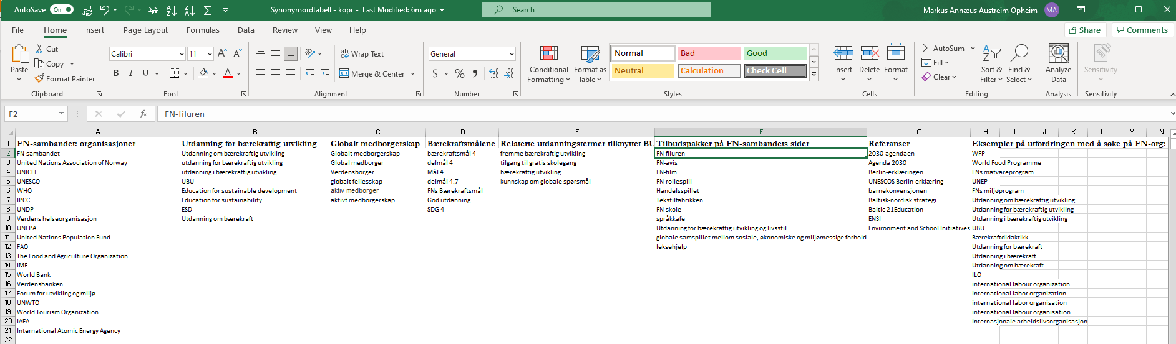

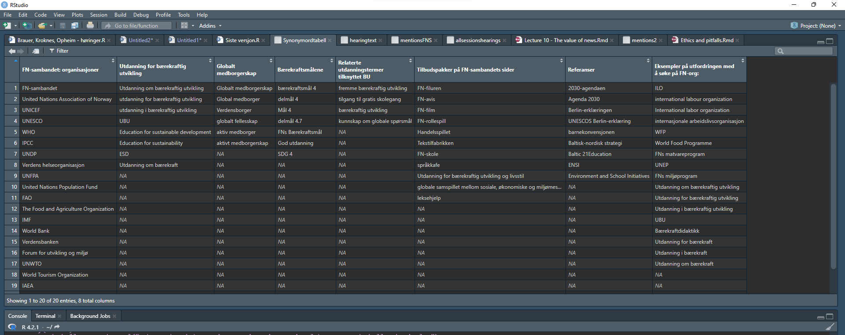

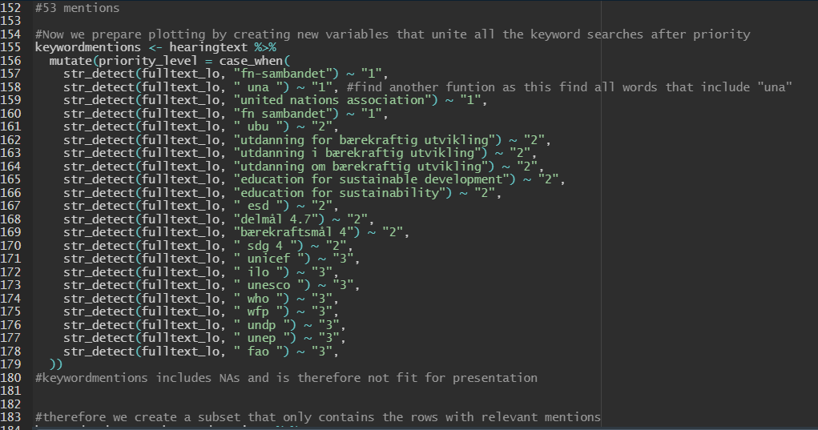

Another issue with applying the search words in our R code is that the Stortingsscrape-package we have based our solutions on cannot import skriftlige innspill (written inputs), so that some results are omitted. For example “utdanning for bærekraftig utvikling” and “delmål 4.7” was used by another actor than FN-Sambandet in a written input from Naturfagsenteret v/ Universitetet i Oslo”. Possibly, that is a challenge in other applications if for example many usages of words occurred in such written inputs.